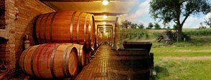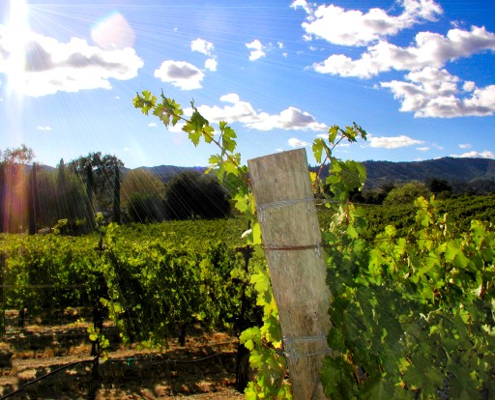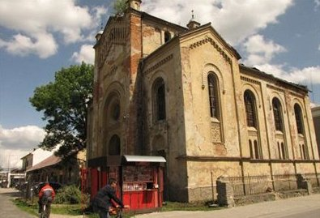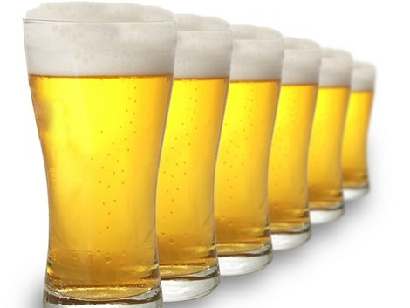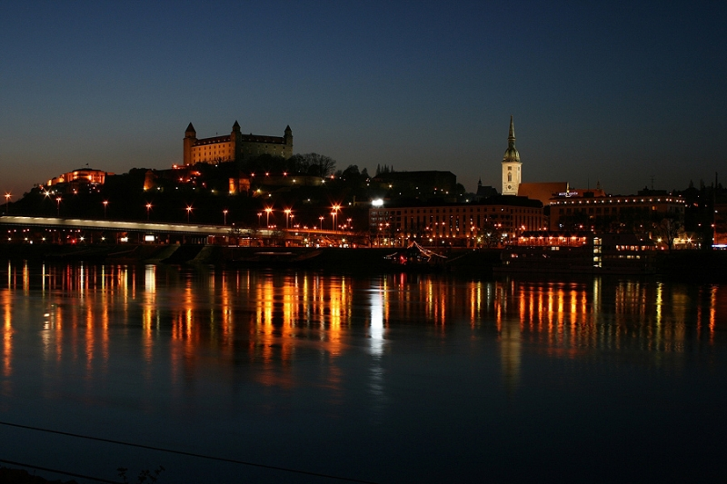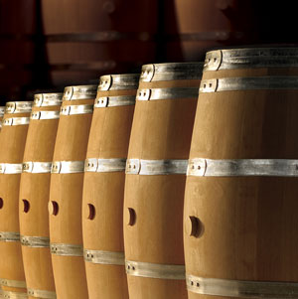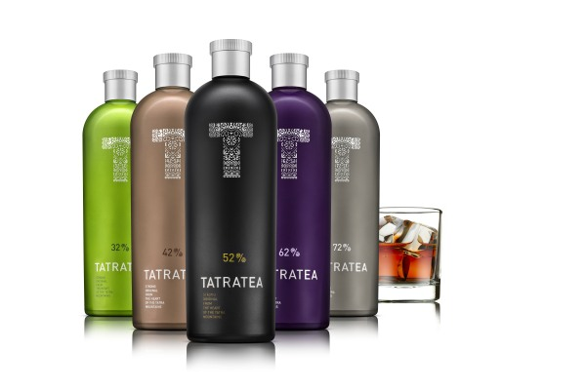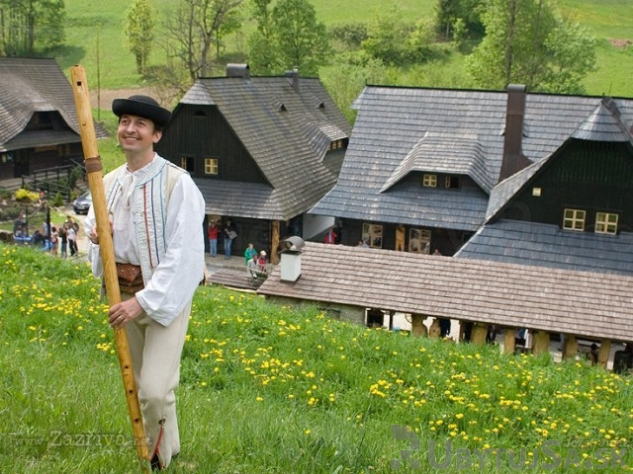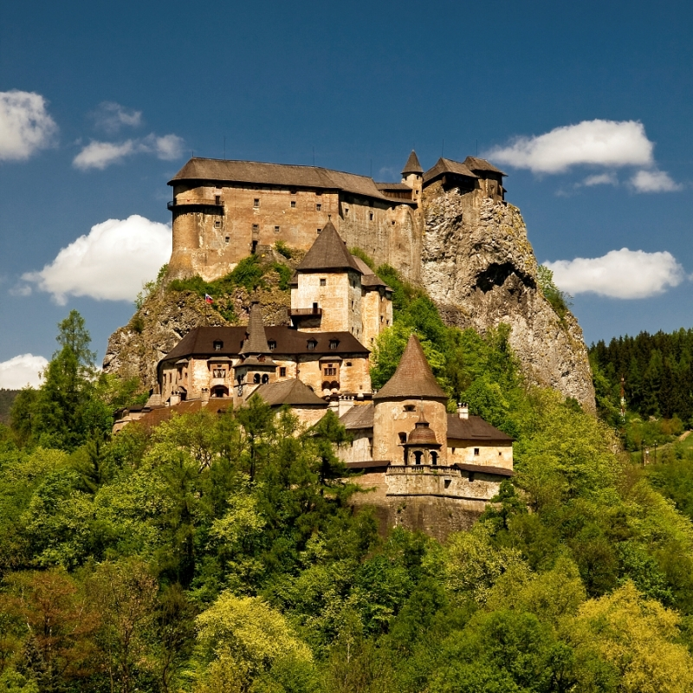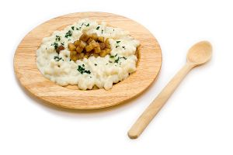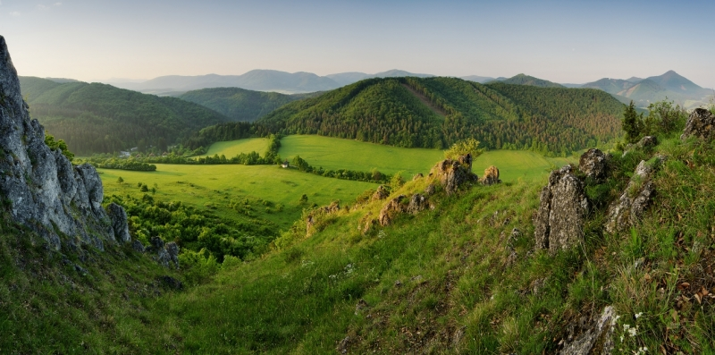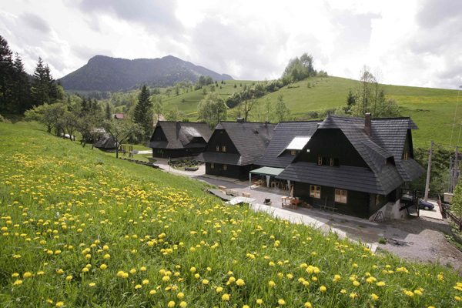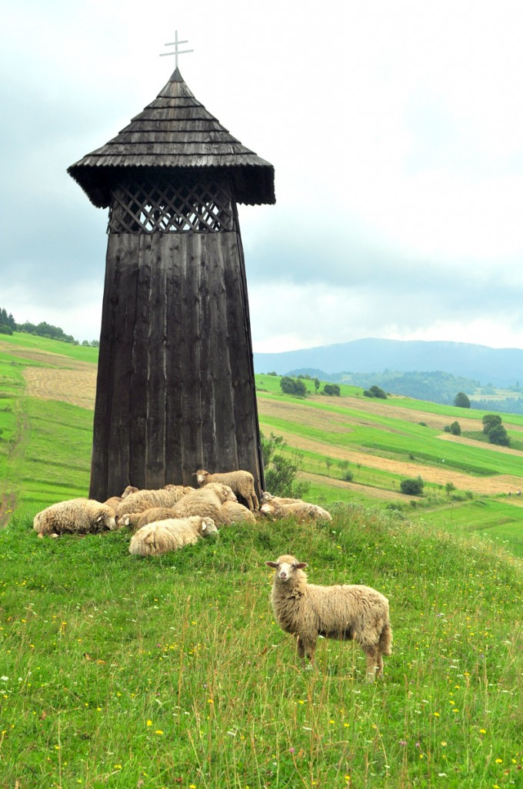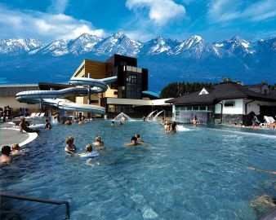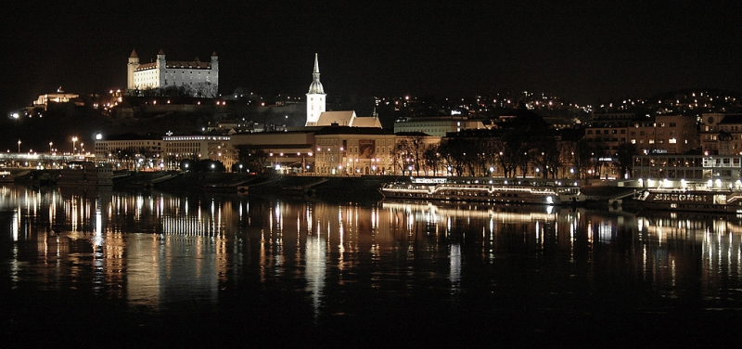

ITINERARY

**DAY 1 - Welcome to Bratislava**

Welcome at the airport, transfer to the hotel by personal tour guide who will explain all the details about your trip. Welcome Dinner & overnight stay in Bratislava.

**DAY 2 -** **Bratislava, Modra**

Breakfast at ~8 am followed by meeting with your tour guide at the hotel and start of the tour of Bratislava – the capital city, visiting attractions such as:

* Primate‘s Palace – a marvelous Classicist and largest palace in Bratislava where the Treaty of Pressburg was signed in 1805St.
* Martin‘s Cathedral – one of the largest Gothic constructions in Bratislava where the coronations of 19 rulers took place between 1563-1830, including Austro-Hungarian empress Maria Theresa
* Michael‘s gate – the only preserved city gate, ranking among the oldest town buildings
* Historic narrow old town streets, squares, Slovak National Theatre and the historic Bratislava castle.

During the tour we will stop for a lunch in the city centre

Later in the afternoon enjoy unlimited consumption of alcohol beverages during the tasting tour - we’ll depart to the family owned vineyard near Modra. Whether you are a first-time visitor, wine novice, or an experienced connoisseur, we will create an experience to meet your needs. Your guide knows the wine country like the back of his hand, so you can rest assured he will make the best use of your valuable time. During the day, you can dine outdoors surrounded by vineyards at a scenic winery, or enjoy lunch in one of the cellars. Dinner & overnight stay at a wine cellar in Modra.

**DAY 3 –** **Bytca brewery, Zazriva, Janosikov dvor**

Breakfast at ~8 am, transfer to **Beckov** (about 1hr drive); tour of the beautiful Beckov castle. It is located apx. 16 kilometers south of Trencin at a place where the river Vah finishes its journey through the Trencin's valley and enters the lowlands of Dunaj. The castle lies on a steep 30 meters high rock over the village of Beckov. It is one of the oldest castles of former Hungary and Austro - Hungarian Empire.

**Tour of Bytca brewery** - The Popper Brewery - one of the smaller breweries in Slovakia with rich history and tradition reflected in the range and quality of their brands of beer - Popper and Palatine. Enjoy unlimited consumption of alcohol beverages during the tasting tour.

* Popper brand includes a range of 10, 11 and 12 degree light lager beers and a 10 degree dark lager.
* Palatine brand includes a selection of 12 and 16 degree dark lagers.

Popper Brewery still produces its beer the traditional way as opposed to large volume breweries with their latest technologies which produce beer that is hardly different from any other large brewery due to the loss of human aspect in the art of brewing. Popper brewery's goal is to make unique products that will be identified by consumers from other brands for its unique and original taste.

**In Slovakia**

Wine, Beer and Liquor tasting tour

EnjoySlovakiaTours.com

Sed porttitor imperdiet odio. Sed ut leo.

Later in the afternoon we will transfer to **Jánošíkov Dvor (Janosik's Court) in Zazriva**, situated beneath the peaks of Malý and Veľký Rozsutec in the beautiful surroundings of Malá Fatra National Park. The unique cottages of Janosik's Court preserve the original impression of traditional Slovak folk architecture and will enhance your feeling of being connected to the nature and intensify the enjoyment of your leisure time.

* The program will include a Slovak cultural heritage musical instrument “fujara”. You will have a unique opportunity to learn and play the instrument. In addition to getting the hands-on experience playing Fujara, you will also learn about its origin, craft of making it, the traditional decoration and hand carving of this instrument and much more. Fujara class is for everyone who wants to feel and experience the Slovak folk tradition.

Dinner & overnight stay in Janosik's Court

**DAY 4** - **Orava Castle, Skanzen Zuberec, Wellness aquapark Oravice**

Breakfast at ~ 8 am, transfer to Zuberec to visit the Orava SKANZEN – The Museum of Orava Village – an open air museum of folk architecture exhibits, intact rural houses brought from all around the region of Orava and re-assembled in Zuberec. The gardens and fields around the houses show various ancient forms of farming and animal husbandry.

Later in the afternoon transfer to Orava Castle, built on a natural rock formation known as “castle cliff” high above the Orava river. It is considered to be one of the most beautiful and most visited castles in Slovakia. The castle was built in the thirteenth century. Many movies were filmed here, including scenes from the 1922 black and white movie “Nosferatu” (adaptation of Bram Stoker’s Dracula). Orava Castle stands on the site of an old wooden fortification, built after the Tartar invasion of 1241. Its history since then reveals a familiar pattern of construction, destruction, reconstruction, fire, various ownerships and territorial squabbles. The original design was in Romanesque and Gothic style, it was later reconstructed as a Renaissance and Neo-Gothic structure.

Finish the day of activities by relaxing and enjoying thermal wellness aqua park in nearby Oravice.

Dinner & overnight in Zuberec

**DAY 5** - **High Tatras , Tatra tea tasing**

Breakfast at ~8 am, transfer to High Tatras – the dominant and most popular mountain range on the borde between Slovakia and Poland. The rugged High Tatras with 17 peaks over 2500 meters high are togethe with the Southern Carpathians the only mountain ranges with an alpine character in the 1200 km length of the Carpathian Mountains.

* Most of High Tatras with all of its highest peaks are situated on the Slovak side of the border with Poland.
* The highest peak is Gerlachovský štít (2,655 m). Many rare and protected animals and plant species are native to the High Tatras which are also home to Eurasian lynx, bears, marten, wolves, fox and others. The area is well known and popular year round. Ski resorts include Štrbské pleso, Starý Smokovec and Tatranská Lomnica in Slovakia, and Zakopane in Poland. The town of Poprad is the gateway to the High Tatras resorts.

Planned tour include Stary Smokovec area and a short walk around Strbske and Popradske pleso (lake).

We will finish the day with the tour of KARLOFF distillery which is the home of the world famous „TATRATEA“ liquor. Enjoy

**DAY 6 - Demanovska Ice Cave, Aquapark Poprad Tatry**

Breakfast at ~8 am, transfer to Demanovska valley (~1hr drive), followed by a visit of the Demanovska Ice Cave. It was first mentioned in 1299 and remains one of oldest known caves in Europe. It stands out by occurrence of permanent ice fill, bizarre and amazing shapes of underground formations and rare cave fauna.

Finish the day of activities by relaxing and enjoying thermal wellness aqua park in Poprad city.

Dinner & overnight stay in Poprad.

* Flights to/from Slovakia, insurance – can be arranged
* Return airport transfers (can be arranged)
* Lunch, dinner
* Alcoholic & non-alcoholic drinks
* Souvenirs, tips
* Any other trips not mentioned in this itinerary

What is not included:

What is included:

* Your professional guide who will also be your driver, translator & advisor
* Unlimited consumption of alcohol beverages during the tasting tours to vineyard, brewery & tour of the Karloff/ Tatra tea factory.
* 6 nights in a room with double occupancy
* 6x breakfast
* 1x welcome lunch
* 1 x traditional barbecue lunch
* All transfers around Slovakia
* Refreshments
* Fuel and all parking & highway tolls
* Map of Bratislava & map of Slovakia, information material (brochures, leaflets)
* Entrance fees to all museums, spa and other attractions
* Personal CD-ROM with Photos of your trip

**DURATION: 7 Days / 6 Nights**

**BEST TIME OF THE YEAR: All year round**

**PRICE PER PERSON: 1390 € twin share**

**DAY 7 - Good-bye Slovakia**

After the breakfast, check-out and transfer to Bratislava you will have a free time for last minute shopping & spend time in the City Centre of Bratislava until your transfer to the airport.

*www.enjoyslovakiatours.com*

*Email: info@enjoyslovakiatours.com*

*Phone: +421/904 292 468*